Constructing Polygons with Porcupine Quills

Subject: Mathematics Creator: Alison Kimbley
Strand: Shape and Space Grade: 6
Content (topic)

Exploring Regular and Irregular Polygons
Outcomes  SS6.3: Demonstrate understanding of regular and irregular polygons including:  - Classifying types of triangles  - Comparing side lengths  - Comparing angle measures  - Differentiating between regular and irregular polygons  - Analyzing for congruence. | Indicators  SS 6.3a: Observe examples of polygons, including triangles, found in situations relevant to self, family, or community and sort the polygons into irregular and regular polygons.  SS 6.3b.: Analyze the types of triangles (scalene, isosceles, equilateral, right, obtuse and acute) to determine which, if any, represent regular polygons.  SS 6.3c: Analyze a set of regular polygons and a set of irregular polygons to identify the characteristics of a regular polygon.  SS 6.3d: Draw and classify examples of different types of triangles (scalene, isosceles, equilateral, right obtuse, and acute) and explain the reasoning.
Lesson Preparation
Equipment/materials:
- Two packages of toothpicks
- White glue or fabric glue
Advanced Preparation:
- Prepare the toothpicks or have the students dye the tips of the toothpicks. To dye toothpicks use food coloring, and soak the tooth picks overnight (make sure the dye covers the toothpicks.)
- The students will need to be able to identify triangles as scalene, isosceles, equilateral, right, obtuse or acute
Presentation
Development
- Explain to students that porcupine quills were commonly used for decorative artwork for Aboriginal groups that lived in the woodlands where the porcupine could be found. Clothing, weapons, baskets, personal items, tools, and sacred items were the beneficiary of this unique and amazing art form. Quills were dyed to create shades of: Black, white, red, and yellow.
- Show students Appendix A to see some of the artwork created by quills.
- Provide the students with a number of dyed toothpicks and share with the students that these toothpicks symbolize quills. In the quillwork of Aboriginal groups the quills were often arranged in geometrical designs.
- Have the students create such a design on thick paper such as construction paper or Bristol boards, tell students that they may want to cut the toothpicks to create the desired design.
- The designs created by the students are to include at least one of each of the following triangles (scalene, isosceles, equilateral, right, obtuse, and acute) and after the students have created those and have them determine which represent a regular polygon.
- Explain to the students that regular polygons have rotational symmetry.

Appendix A
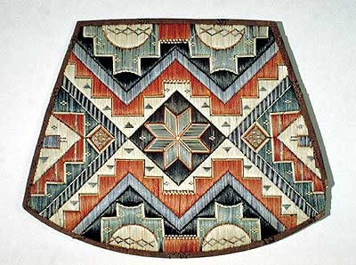
Micmac quillwork chair seat (courtesy Glen bow Museum/Canadian Ethnology Service, CMC).

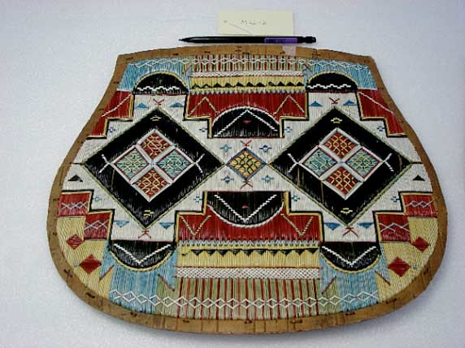
University of Delaware

